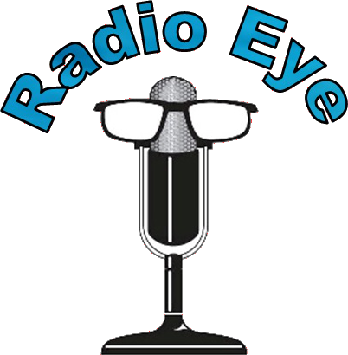
2020 ANNUAL REPORT

9,777
LISTENERS

1 NEW WAY TO LISTEN
Now listeners can tune in to their favorite Radio Eye podcasts by enabling the Radio Eye Podcast Player skill on their Amazon Echo and saying, "Alexa, open Radio Eye podcast player."
139,959
WORLDWIDE PODCAST
DOWNLOADS

148
VOLUNTEERS
Volunteers gave 4,744 hours of their time, recording Radio Eye programming in their homes and businesses

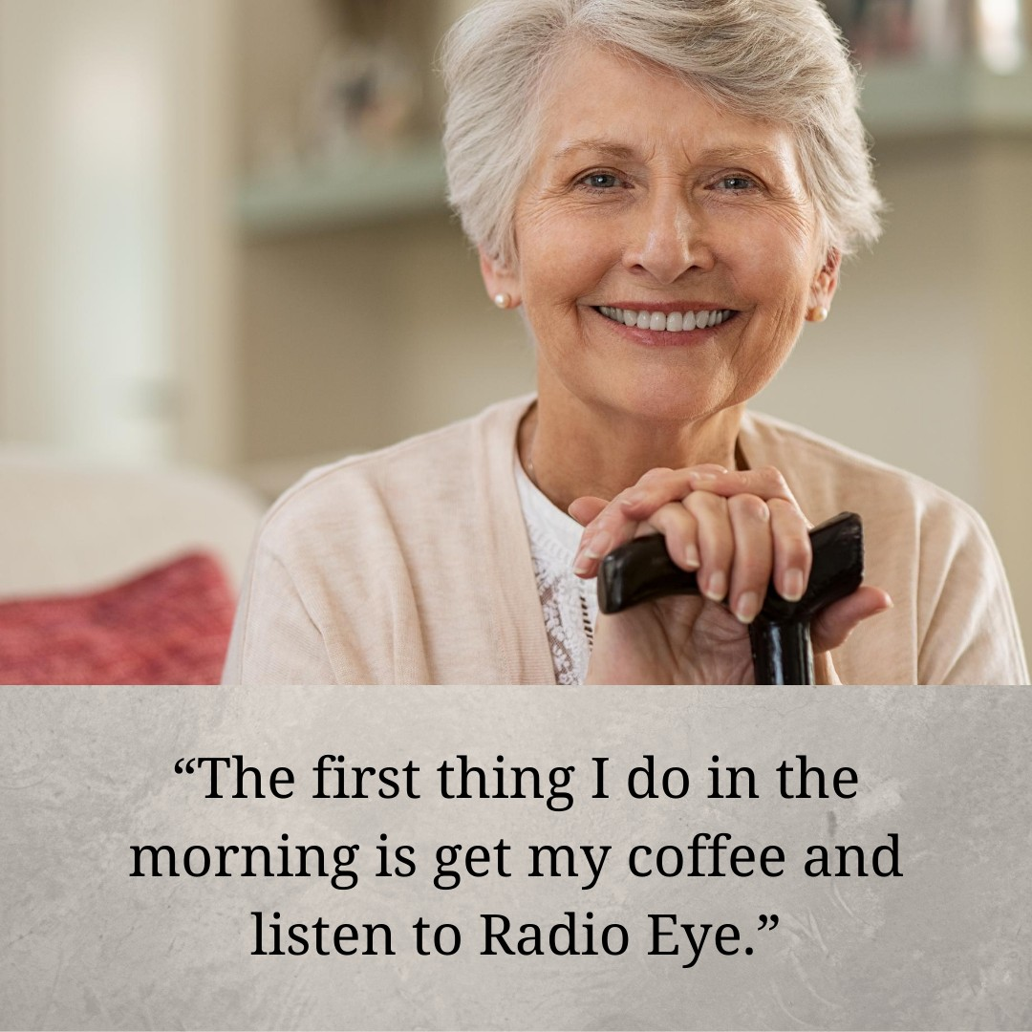
COVID-19 CHANGES
Last day for in-studio reading was March 13, 2020

Remote reading by volunteers and staff began March 15, 2020

Reopen date for Lexington studio: June 7, 2021

Reopen date for Louisville studio: TBD

Listener Survey
This year, we conducted a survey of 61 listeners. Listeners listened to an average of 7 programs.

Favorite Shows on Live Broadcast
- Lexington Herald Leader - 61%
- Louisville Courier Journal - 49%
- Regional Newspapers - 43%
- New York Times, English - 37%
- Book Series - 29%
- Tie between: Grocery Show, Hope & Inspiration/Breathe, and Sports News - 18%
- Health Corner - 16%
- Tie between: Frankfort State-Journal, Lexington Business News, Magazine Rack, and Sound Prints - 14%

"Radio Eye keeps me updated on the news. It's a good source for news and all civil events." Listener Charleston

"Radio Eye has been worth its weight in gold these last six months," listener Patricia, said in September 2020

Most Popular Podcasts
  - New York Times, English
  - National Geographic Magazine
  - KY Spanish News
  - KY Spanish Stories
  - Smithsonian Magazine
  - Louisville Courier Journal
  - Book Series books
  - Lexington Herald Leader
  - AARP Magazine
  - People Magazine

How Listening to Radio Eye Affects Their Lives
87% feel less isolated*
88% feel happier since starting to listen to the programming 85% feel more informed about political candidates
69% talked with their family and friends about something they heard on Radio Eye
58% know more about health issues affecting them or their community 61% know more about health issues affecting their community
11% attended an event they only heard about through Radio Eye (in person or virtual)
5% have talked to their doctor about something they heard on Radio Eye health programs
* of the 61% who said their disability made them feel isolated

LISTENERS BY REGION

1,217 HOURS OF PROGRAMMING

Central Kentucky: 3,676
Greater Louisville Area: 3,280 Eastern Kentucky: 912
Morehead: 80
Western Kentucky: 14
Unknown: 1,610

LISTENED TO BY PHONE

Listeners by Broadcast Type Radio Eye provided device: 394 Hospital and other organizations:
6,150*
NFB-Newsline: 2,158* TV: 444*
Podcast: 498* (1)
Website: 124* (2)
Toll-free number: 9* (3)
Total: 9,777
* Does not include listeners who listen via a Radio Eye provided device.
- Average listeners per month, assuming each listener listens to 7 programs.
- Average listeners per month in Kentucky, based on IP address
- Average number of unique phone numbers calling in each month.
Lexington
1733 Russell Cave Road Lexington, KY 40505
800-238-5193 ext. 1010 or 502-565-
1914
info@radioeye.org

Louisville
1906 Goldsmith Lane, Family Library of VIPS, Louisville, KY 40218
502-509-5184
louisville@radioeye.org

Eastern Kentucky
606-233-1330
sharon.cornett@radioeye.org

Social Media Facebook: Radio Eye Twitter: @RadioEyeKY
Instagram: @radioeyelexington Newsletter: eepurl.com/d6JF9

Officers and Board of Directors
David Hafley – Chair, The Thrasher Group John Copeland – Treasurer, Blue and Co., LLC
Alice Dehner – Secretary, Community Volunteer Chris Clements – Retired Senior Volunteer Program (RSVP)
D. Robert Deal – JRA Architects
Melanie Kilpatrick – Rajkovich, Williams, Kilpatrick & True Laura H. Mitchell, O.D. – Simpson Optical
Rick Roderick – Community Volunteer Philip Rose – Community Volunteer Kyle Wicker – Republic Bank

Thank You to Our Supporters
We would like to thank the following people and organizations for their support this past year: Alex G. Campbell Foundation, Anonymous x6, Appalachian Community Fund, Beulah S. May Charitable Endowment, BLUEgrass Runners, Dr. Leslie Branch, MD & Mrs. Barbara Bennett, CRNA, Ron and Susan Byars, Community Foundation of Louisville, Rob Deal, Gary and Alice Dehner, Delta Dental of Kentucky Making Smiles Happen Fund, Melinda Evans, Fred B. and Opal S. Woosley Foundation, Eugene Gholz and Rose Kelanic, Good Samaritan Foundation, Group Six, Inc., David Hafley and Janet Shedd, Muzzy Hemken, Larry and Sue Hurt, Jerome S. & Grace H. Murray Foundation, JRA, Architects, Kentucky School for the Blind Charitable Foundation, Nelson and Mary Jo Lamkin, Lexington Lions Club, Lexington Medical Society Foundation, Inc., LFUCG Community Development Block Grant, Linda Neville, Link-Belt Construction Equipment, Louisville Downtown Lions Club, Morning Pointe of Lexington, Dennis Pearce, PNC, Fon & Mac Rogers, II, Philip Rose, Dave Russell, Deano and Shandra Sarantakos, Second Presbyterian Church, Darryl Stith and Samye Miller, The Carl Family Foundation, The Cralle Foundation, Inc., The Gilbert Foundation, The Rotary Club of Lexington, Julie Thro, Jewel Vanderhoef, Walmart #4414, and the Lexington Herald-Leader and dozens of other publishers who donate their publications.

FUNDING

Revenue: $293,798 Expenses: $234,243
Donations from Corporations and

Foundations: 41%
Reserve Fund/Endowment Income: 23% Donations from Individuals: 21% Government Funding: 14%
Sponsorships: 1%

In-Kind Donations: $115,100 – from volunteers, community partners, and other supporters
Payroll Expenses & Benefits: 71%
Equipment: 7%
Supplies, Postage, and Printing: 6% Professional Services: 6% Travel and Training: 3%
Miscellaneous: 3% Dues and Subscriptions: 2%
Insurance: 2%

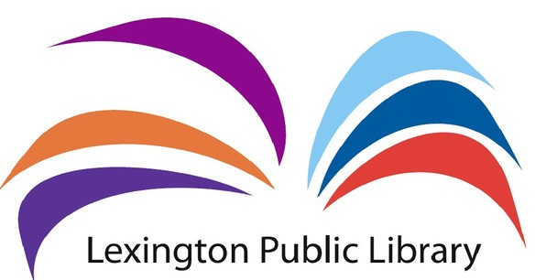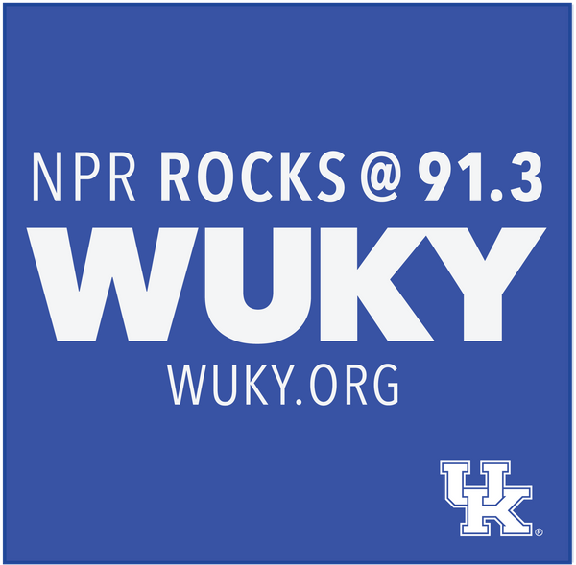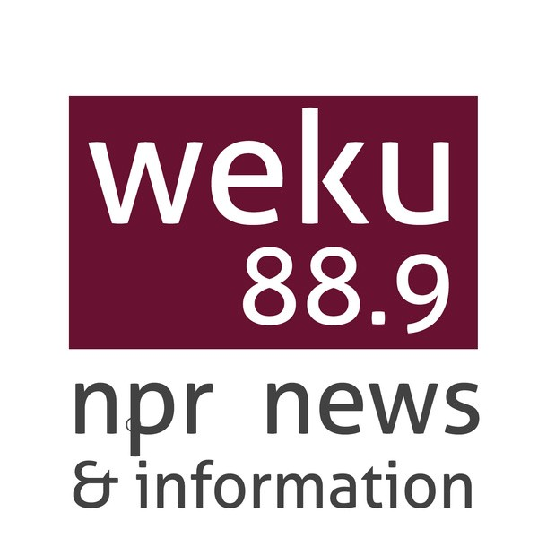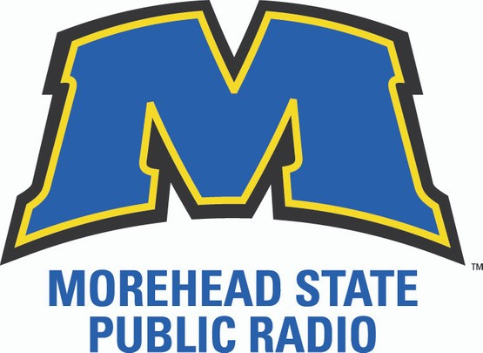
In Reserve Fund at Year End: $644,731 Endowment at Blue Grass Community Foundation: $11,335

A Special Thanks to Our Community Partners!

